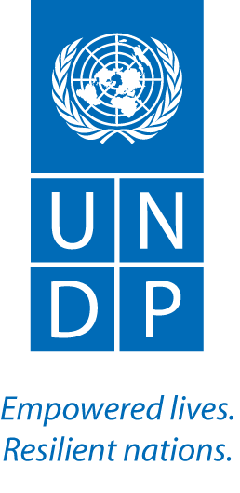
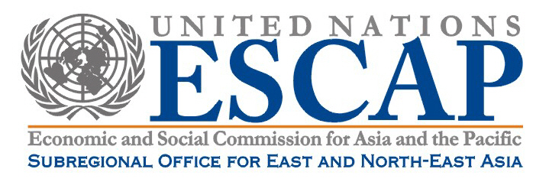

North-East Asian Youth Conference:
“The World We Want”

International Studies Hall. 2nd Floor, Graduate School of International Studies
Korea University, Seoul.

AGENDA

7th January
‘Lessons from the Millennium Development Goals’
08:30 – 09:00 | Registration of participants
09:00 – 10:20 | Welcome plenary  Welcome addresses:  - Anne-Isabelle Degryse-Blateau – Director, UNDP Seoul Policy Centre (5 mins)  - Kilaparti Ramakrishna – Director, UNESCAP Subregional office for East and North-East Asia (5 mins)  - Sung Hoon Park - Korea University Graduate School of international Studies (5 mins)  - Jungsoo Hur - Global Compact Korea Network (5 mins)  Keynote addresses:  - Jose Dallo – UNDP Bureau for Development Policy: ‘Global Development post-2015’  (15 mins)  - Ravi Karkara – UN Advisor on youth: ‘Youth and post-2015: making your voice heard’ (15 mins)  Participants Country Representatives to introduce teams
10:20 – 10:35 | Coffee break
10:35 – 11:00 | Agenda, Housekeeping and summary of participants questionnaires  - Matthew Taylor
11:10 – 11:25 | Ice breakers  Yuko Kitada and Matthew Taylor
11:25 – 12:30 | 4 x Group Discussions – Lessons from the MDGs
12:30 – 13:30 | Lunch
13:30 – 15:00 | Group discussions (moderated)  - 4 Working groups
15:00 - 15:30 | Groups produce written summary of discussions  - Moderators to facilitate written summaries
15:30 - 16:00 | Coffee break
16:00 – 17:00 | Plenary  Reporting on group discussions  - 4 Group representatives  Facilitator: Ravi Karkara  Discussion  All participants
17:00 – 18:00 | Consolidate written summary of the day  - 4 group representatives
Media Team Meeting
- Participants Media Team
Facilitator: Chris Schuepp

8th of January
Day 2
‘The World We Want’
09:00 – 09:15 | Plenary  Introduction to the day’s aims – Ravi Karkara  Agenda and housekeeping - Matthew Taylor (5 mins)
09:20 – 10:45 | Group discussions (moderated)  - 4 Working groups
10:45 – 11:00 | Coffee Break
11:00 – 12:30 | Group discussions (moderated)  - 4 Working groups
12:30 – 13:30 | Lunch
13:30 – 15:00 | Group discussions (moderated) ‘Demands for Policy-makers’  - 4 Working groups
15:00 – 15:30 | Groups produce written summary of discussions
15:30 - 16:00 | Coffee break
16:00 - 16:45 | Plenary  Reporting on group discussions  - 4 Group representatives  Facilitator: Jose Dallo
16:45 -17:30 | Work on the Declaration  Facilitator: Ravi Karkara
17:30 –18:15 | Consolidate written summary of the day  - 4 group representatives
Media Team Meeting
- Participants Media Team
Facilitator: Chris Schuepp
18:45 – 21:30 | Dinner and Cultural event  Hosted by the Global Compact Korea Network

9th of January
Day 3
‘The Declaration and the Handover Ceremony’
09:00 – 09:20 | Introduction  Introduction to the day’s aims and the structure of the declaration  Agenda and Housekeeping (5 mins)
09:25 – 11:00 | Group Discussions (moderated) -‘Demands for Policy makers and the role of youth’  Including producing written summary
11:00 – 11:15 | Coffee Break
11:15 – 11:45 | Plenary  Reporting on group discussions  - 4 Group representatives  Facilitator: Beniam Gebrezghi  Discussion
11:45 - 12:45 | Drafting the Declaration  Facilitator: Ravi Karkara. Matthew Taylor to support
12:45 – 13:30 | Lunch
13:40 –15:00 | Plenary  Finalizing the North-East Asian youth declaration  Facilitator: Ravi Karkara. Matthew Taylor to support
15:30 –16:00 | Registration for the Handover Ceremony
16:00 – 18:15 | ‘The World We Want’ – Public Handover Ceremony  Introduction of Senior Officials from China, Japan, the Republic of Korea and Mongolia.  Launch of the Myworld platform  Jose Dallo – UNDP Bureau for Development Policy (15 mins)  The Declaration  - Reading the declaration (participants) (25 min)  - Reaction by Ambassadors of China, Japan and Mongolia (20 mins)  Arrival of the Korean Minister of Foreign Affairs and Trade  - Keynote speech from the Foreign Minister (10 mins)  - Handing over the declaration (5 mins)  - QandA session with members of the audience (10 mins)  - Group photo at the front of the stage (5 mins)  Closing speeches (20 mins)  - Anne-Isabelle Degryse-Blateau – Director, UNDP Seoul Policy Centre  - Kilaparti Ramakrishna – Director, UNESCAP Subregional office for East and North-East Asia  - Senior Representative - Korea University  - Ambassador Chul Ki Ju – Secretary General, Global Compact Korea Network (5 mins)
18:15 –20:00 | VIP Reception (by invitation only)

